# Staff

* [Home](https://newroots.org/)
* Staff

# **Meet Our New Roots Staff**

#### **Karyn Moskowitz, Founder & Executive Director**

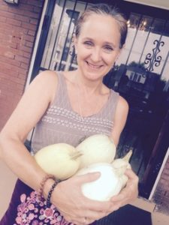

Karyn Moskowitz is a native New Yorker who landed in the Ohio River Valley Region in 1998, experienced first hand the devastating effects of the lack of access to fresh fruits and vegetables, and her life, fortunately, was never the same. She now has 18 amazing years experience as a food justice organizer and social entrepreneur, and is one of the founders of the New Roots Fresh Stop Markets, which she has operated since 2009, in partnership with hundreds of volunteer leaders.

Karyn has received numerous awards for her food and environmental justice work, including being inducted into the Kentucky SISTER (Sisters Inspiring Sisters to Eradicate Racism) Hall of Fame, Heartwood’s Hellbender Award, named 1 of 12 Jewish Women in Environmental Activism by National Women’s Archive, 1 of 10 “Green Jewish Women” honored by Jewish Woman Magazine, two-time food justice delegation leader to Slow Food’s Terra Madre Conference in Italy, recipient of a Rockefeller Fellowship from the Appalachian Center at the University of Kentucky, and was a U.S. Senate Candidate for the Green Party of Oregon.

Karyn holds a B.A. from Boston University in biology and an MBA in environmental management from the University of Washington Foster School of Business and ESCP Europe. She is an engaging and passionate, sought-after speaker and has spoken near and far about fresh food as a right, not a charity or a privilege. She is a proud mom of a 19-year old daughter who loves to eat her Kentucky-grown spinach.

email: karyn.moskowitz@newroots.org

#### **Eneitra Beattie, AmeriCorps VISTA**

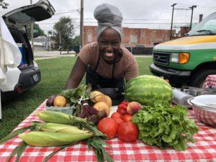

Eneitra Beattie is a native of South Bend, Indiana. She is a recent graduate of the Common Table, Louisville Catholic Charities Culinary Arts Training Program. She heard about New Roots while working as a chef at Brown-Forman’s Bourbon Street Cafe and decided to volunteer to do a cooking demo at a Fresh Stop Market. The rest is HerStory! Eneitra is a now a Growing Roots VISTA AmeriCorp member. She will be completing her year service in May 2019 and will remain involved in New Root’s 2019 West Louisville Fresh Stop Market @ Chef Space.

Her favorite vegetable is green beans.

email: Eneitra.beattie@newroots.org

#### **Amy Edgington, Business Manager**

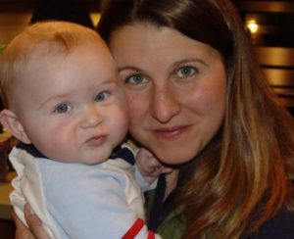

Amy Edgington joined New Roots in 2016. She, along with our other finance superhero board treasurer Gregg Rochman, have been our fearless leaders in organizing New Roots financial management systems. Amy also makes sure Fresh Stop Market farmers are paid when produce is delivered.

Amy is the proud mom of two boys who love to eat their Kentucky veggies.

email: amy.edgington@newroots.org

#### **Chris Coyle, Development Manager**



Chris Coyle hails from the Tell City, Indiana area and has been involved in political campaigns and other movements for many years. He came on board New Roots in October 2018 to launch our Sustainable Roots annual campaign and the Fifty for 50 small and micro-business campaign. When he is not asking you for donations for New Roots incredible food justice work, he is teaching political science and other interesting topics at Bellarmine University and Austin High School.

He cannot wait for the 2019 growing season and begin his love affair with beets.

email: Chris.coyle@newroots.org